Fixed Asset Assignment

Date:13 Dec 2024

**1. Define Asset Categories**

Before assigning assets, you need to ensure that asset categories are set up. These categories define the type of asset, depreciation methods, etc.

1. Navigate to: Fixed Assets > Setup > Asset Categories

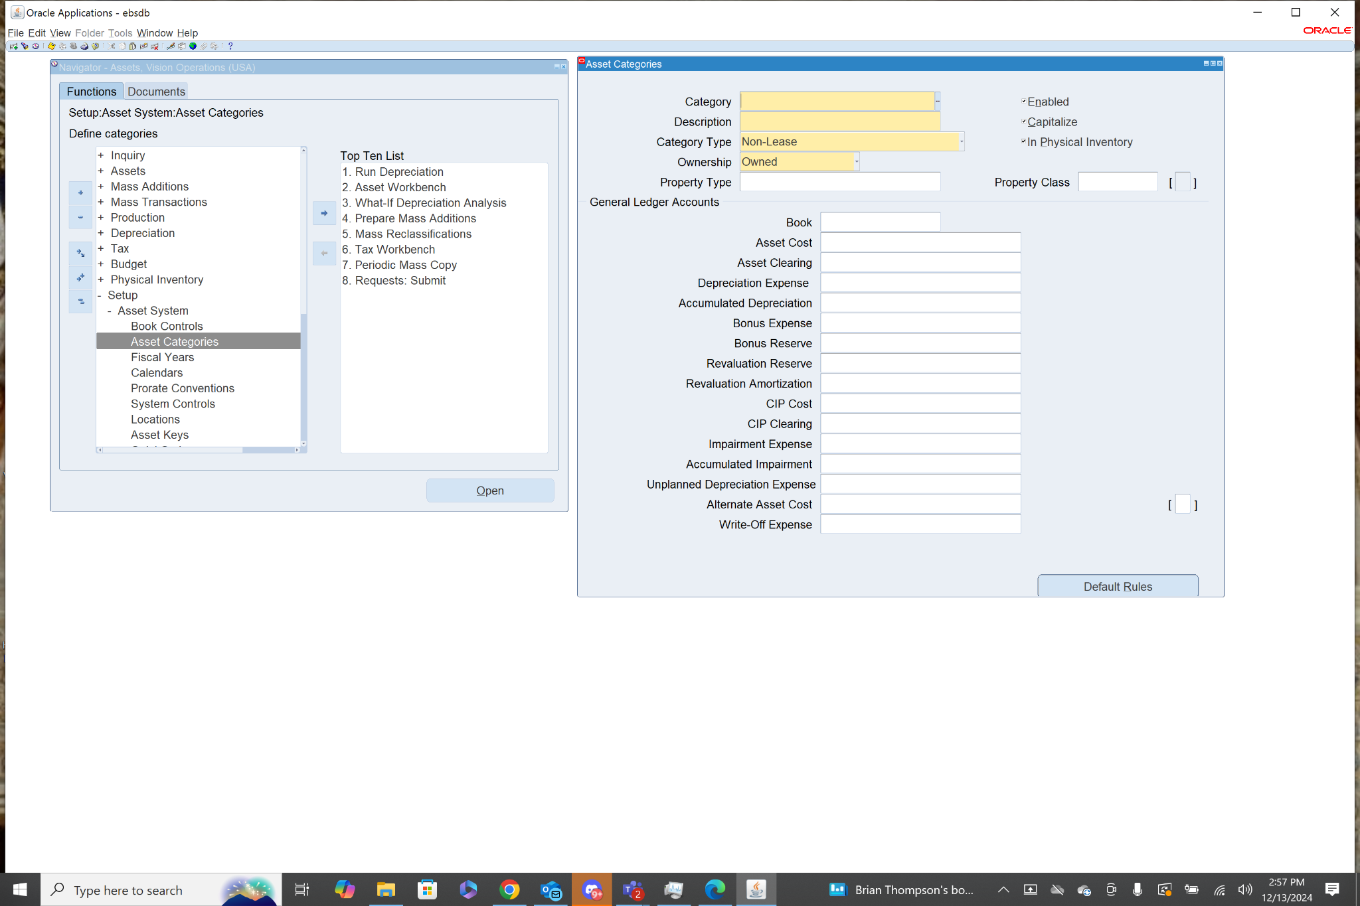

1. Click Create to define a new asset category (if needed), and configure details like:

* Category Code
* Description
* Depreciation method
* Useful life
* Book (e.g., Corporate Book)

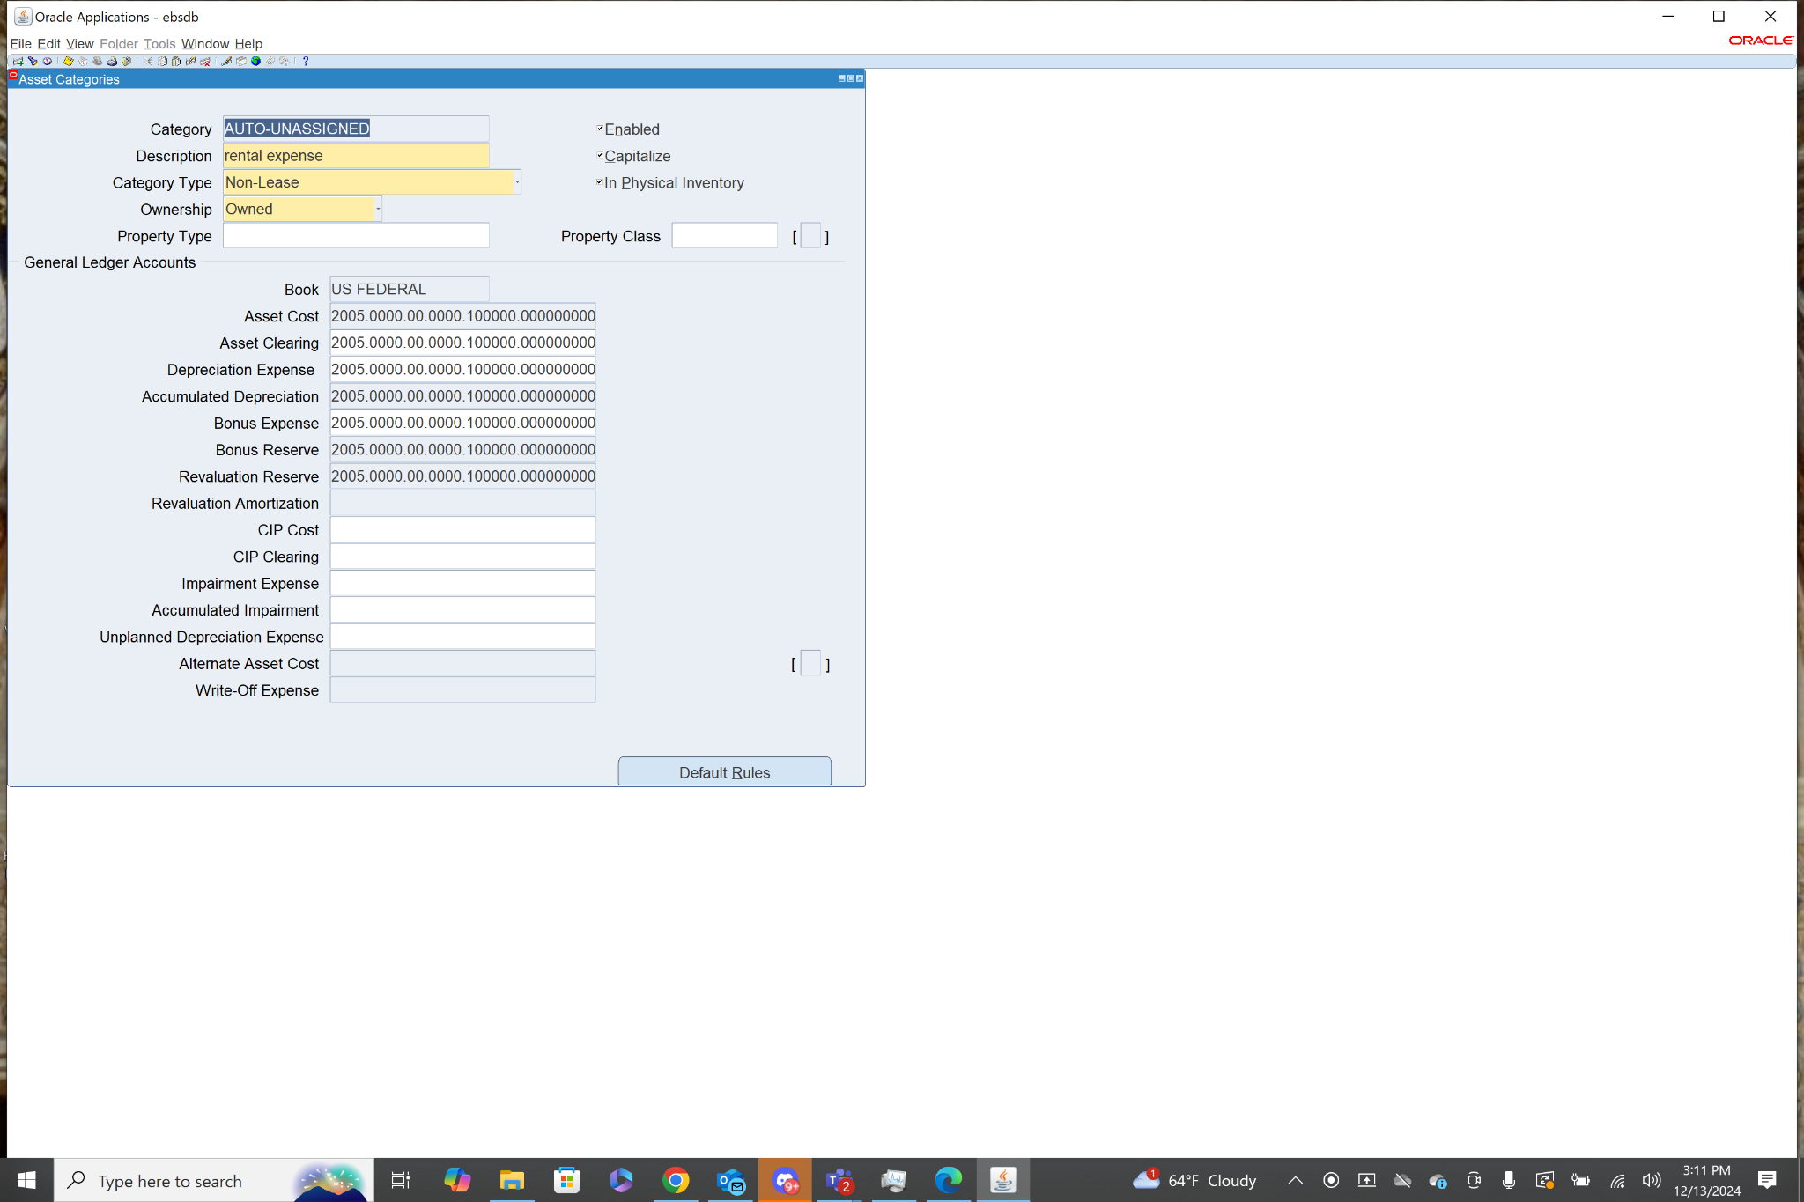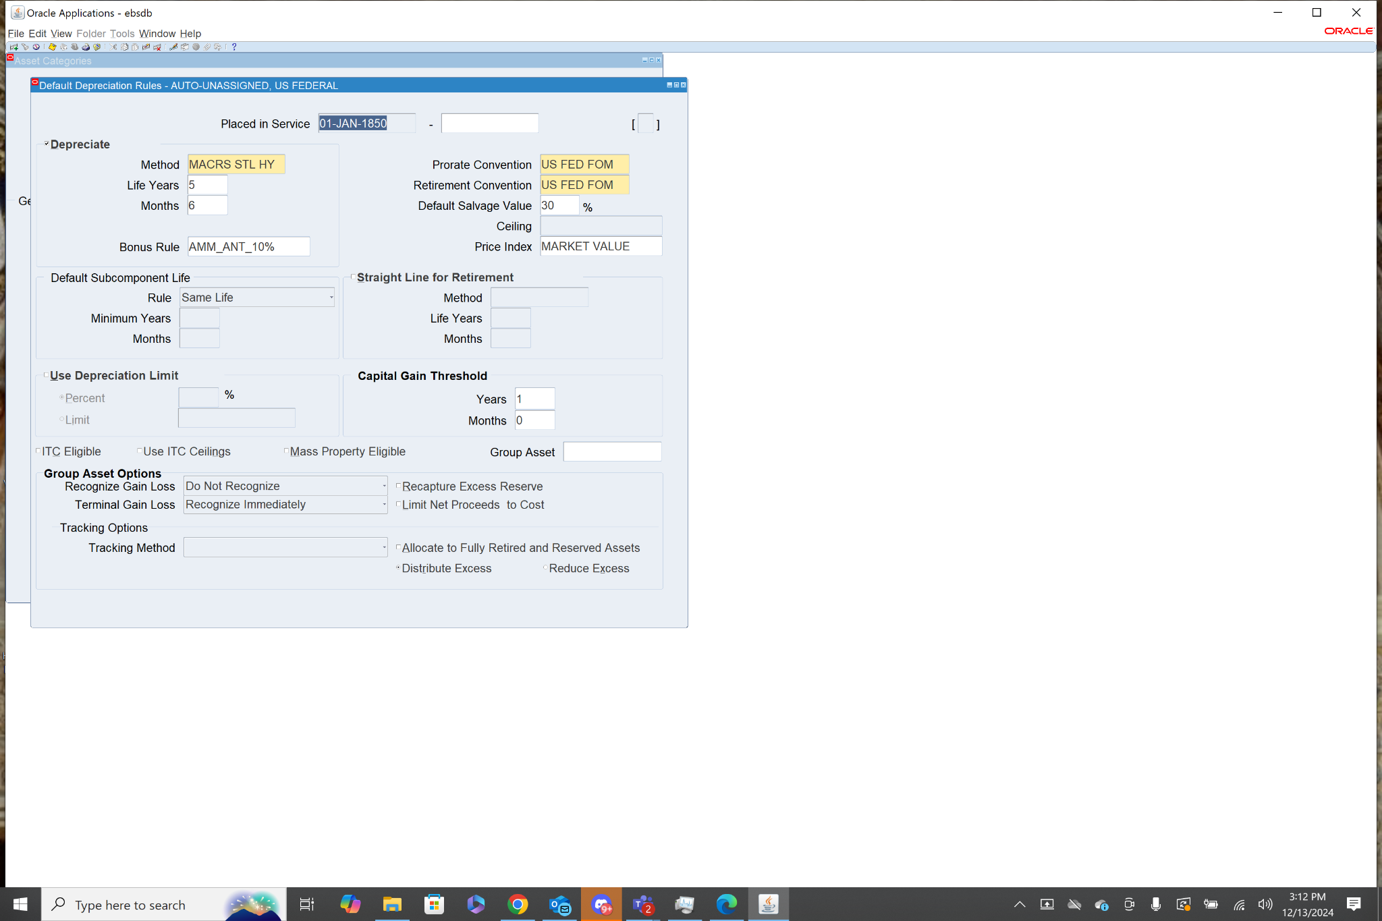

After navigating to asset categories I used fn+f11 to query all asset categories in the system to view their details. The screenshot above on the left shows the general details of the asset category. The screenshot on the right shows the Default rules for the asset category.

**2.Define Locations (Optional)**

Asset locations can be defined for organizational purposes. This can help in tracking assets by location.

1. Navigate to: Fixed Assets > Setup > Locations

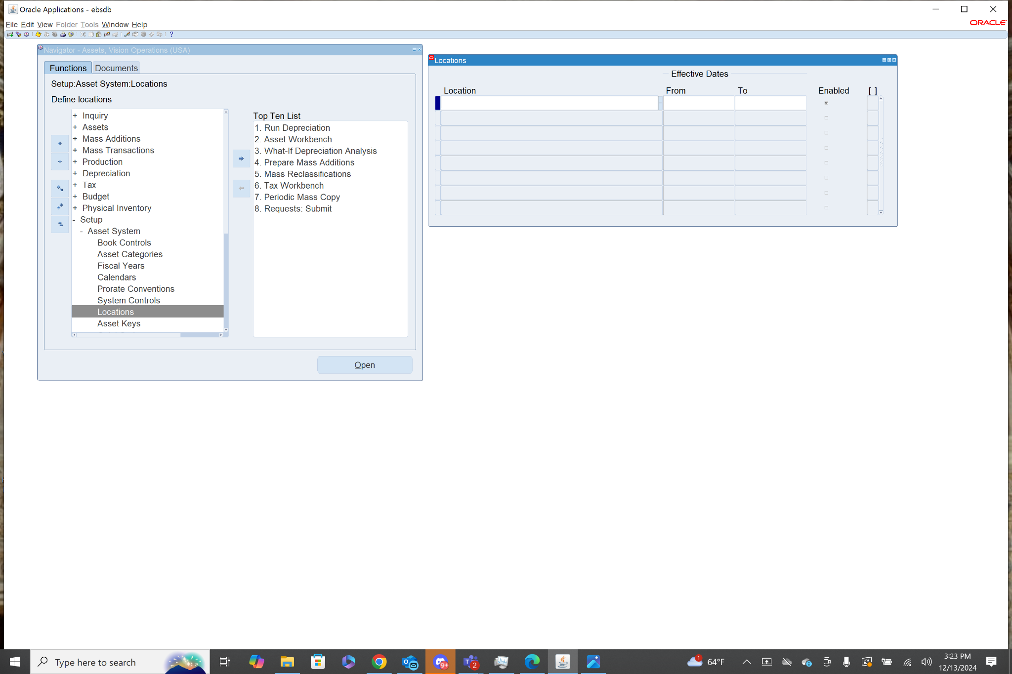

1. Define a new location or review the existing ones.

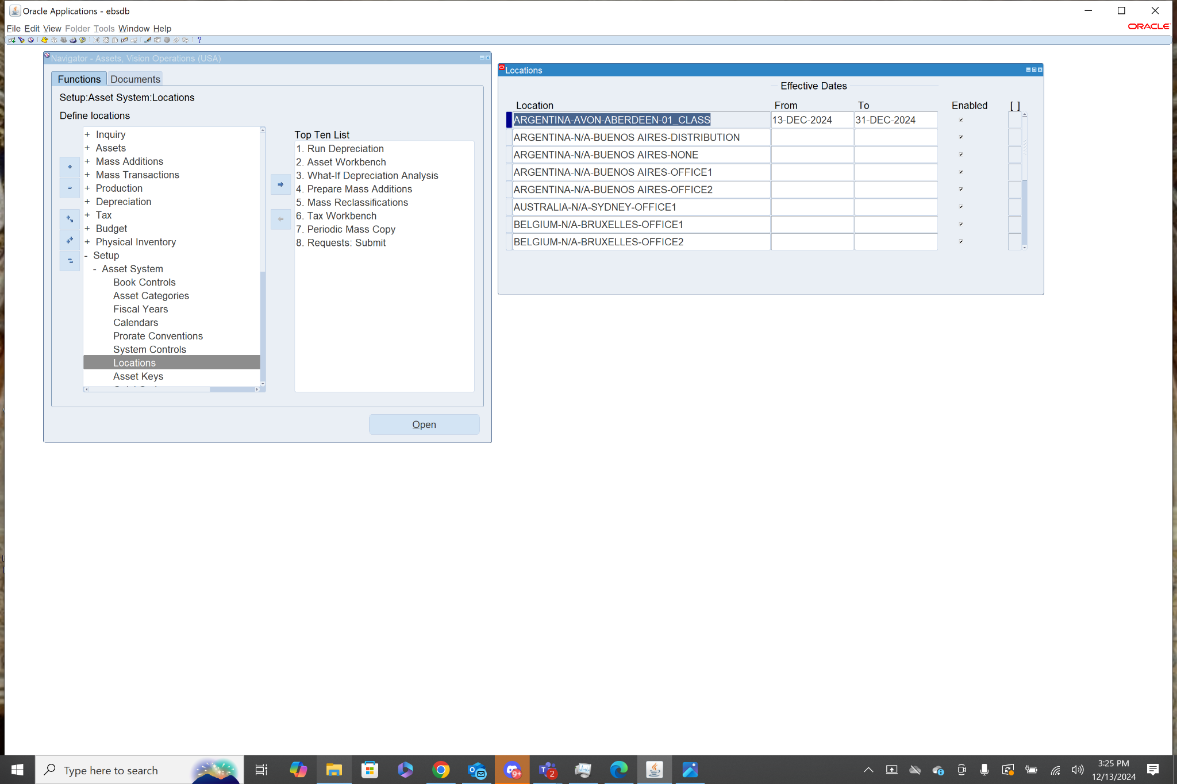

I queried all the locations that are saved in the system. They all appear to have the same naming convention of COUNTRY-STATE-CITY-PURPOSE.

**Step 3: Add an Asset**

After categories and locations are set, you can now assign an asset. This is typically done by entering an asset record with all necessary details such as its category, location, acquisition cost, etc.

1. Navigate to: Fixed Assets > Assets > Add Assets

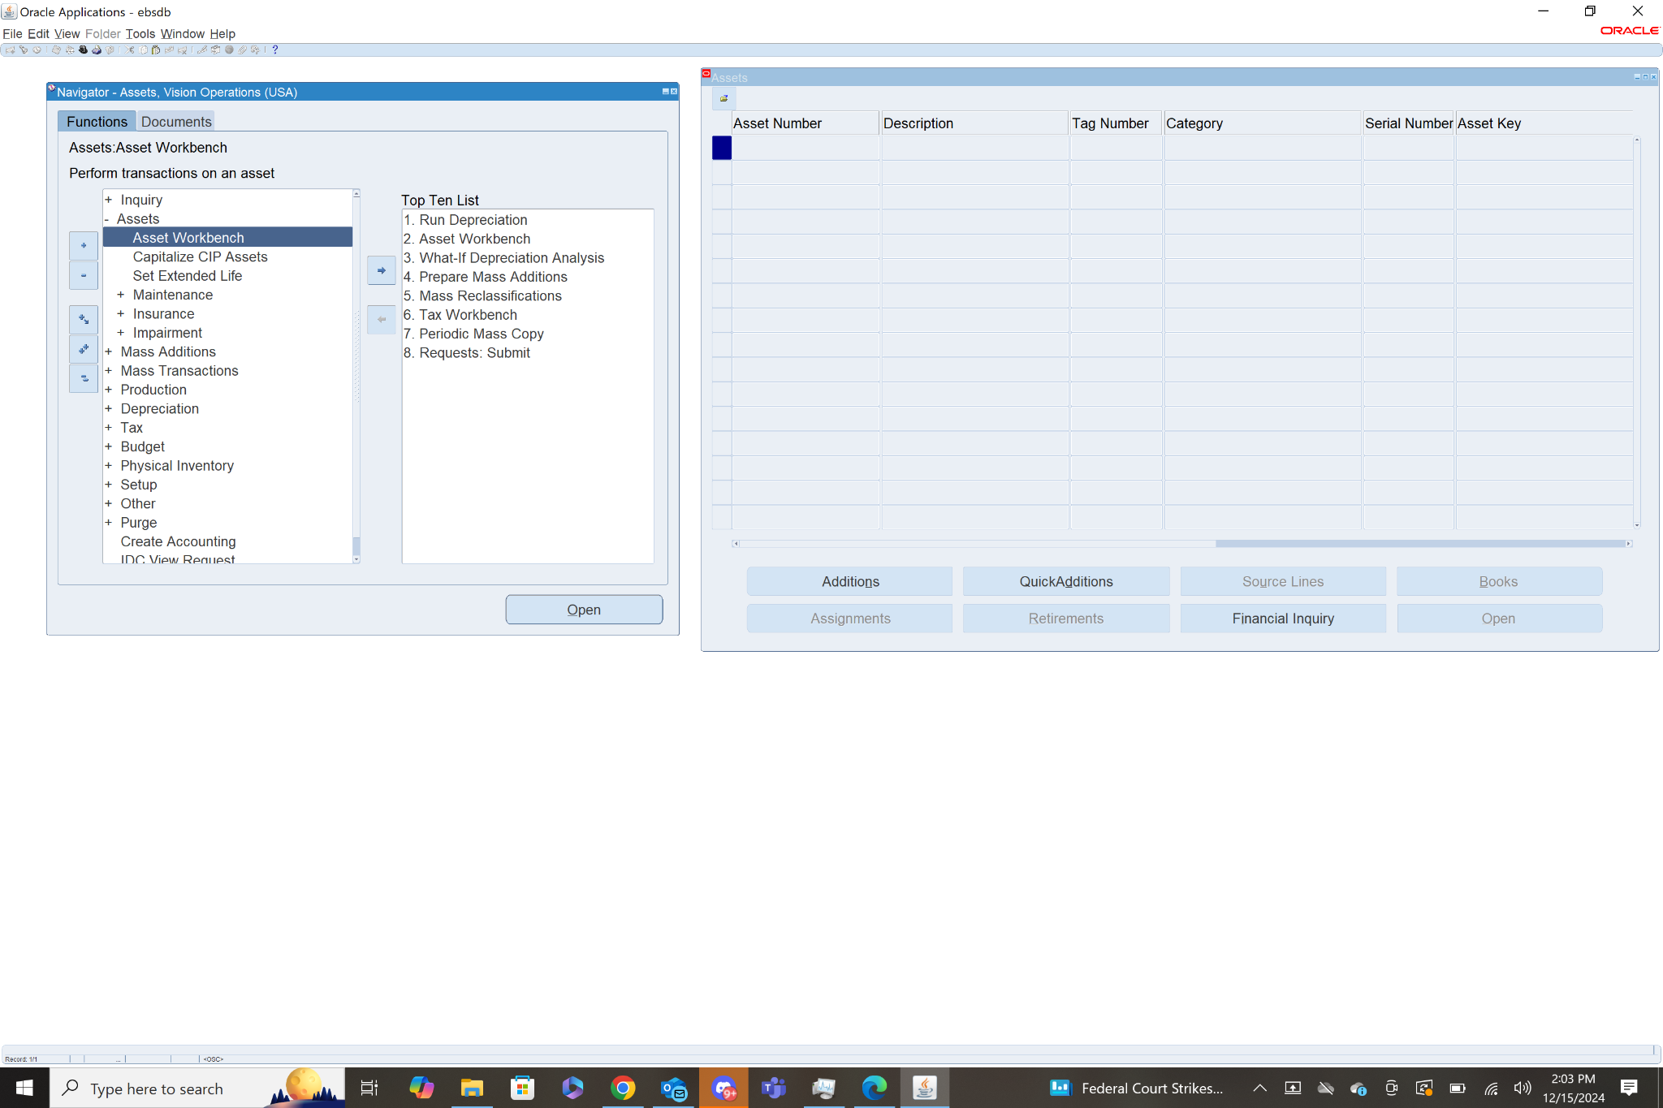

1. Enter details for the asset:

* Asset Category: Select the category from the drop-down.
* Location: Optionally select the asset location.
* Asset Description: Provide a name or description.
* Asset Cost: Input the cost of the asset.
* Acquisition Date: Date when the asset was acquired.
* Book: The book where the asset will be tracked (e.g., Corporate Book).

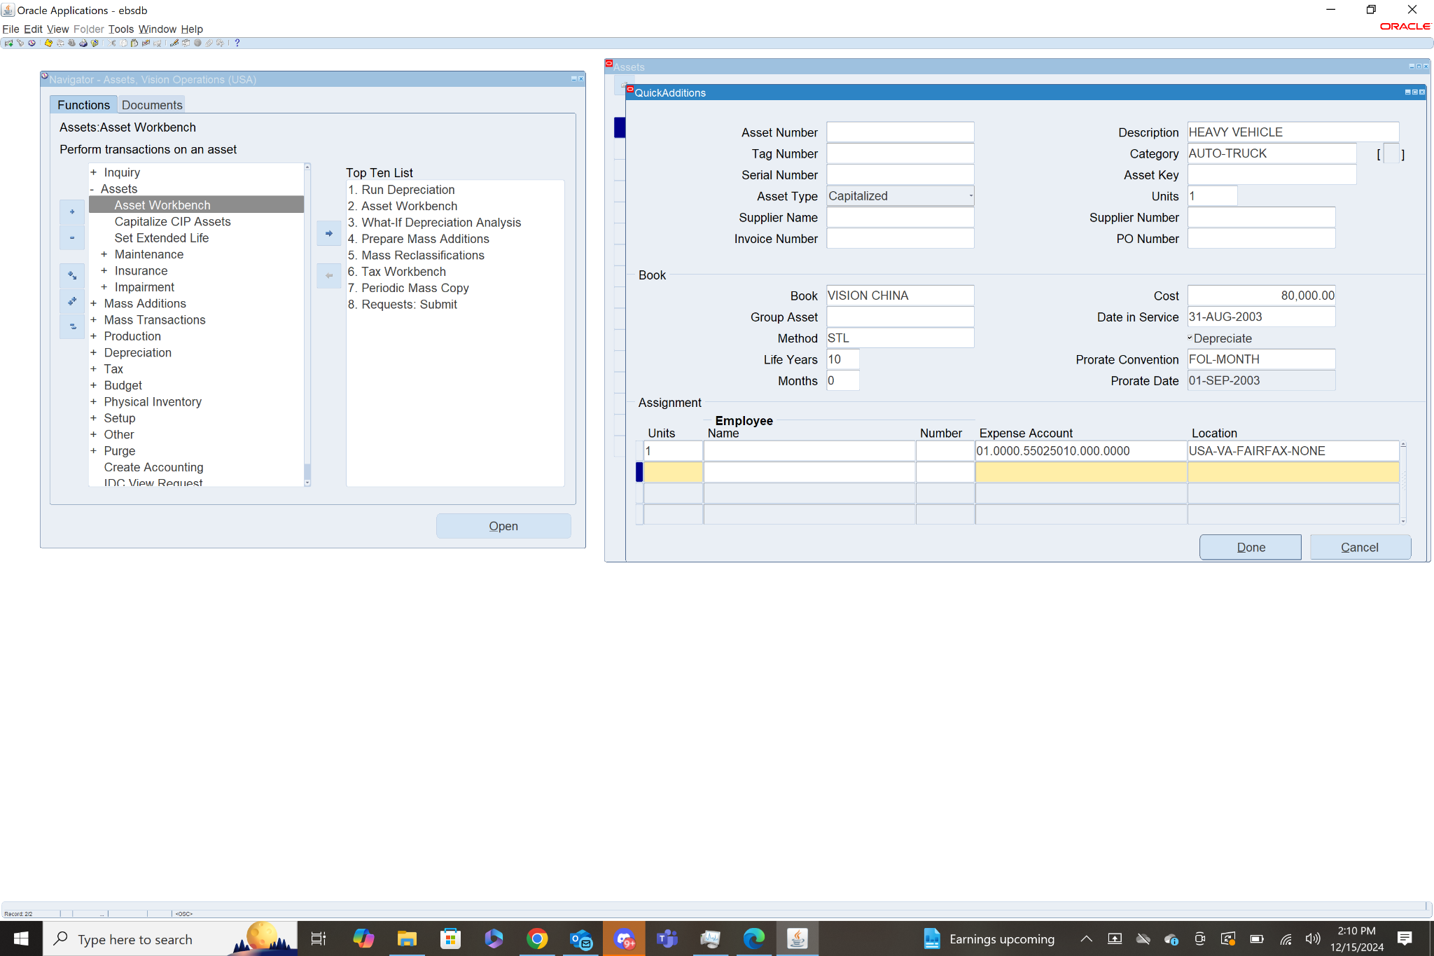

In the above screenshot I created an asset with a description, category, Book, Cost, Location, Date in Service. I tried to use US FEDERAL as the book, but the only option I was given was VISION CHINA.

1. Click Save to save the asset details.

**4: Assign Asset to the User (if applicable)**

If the asset is being assigned to a user or department, you can track this by creating a Transfer or Asset Assignment record.

1. Navigate to: Fixed Assets > Transactions > Asset Transfer
2. Select the asset to transfer and define:

* From Location and To Location.
* Transfer Date.

1. Click Save to update the assignment.

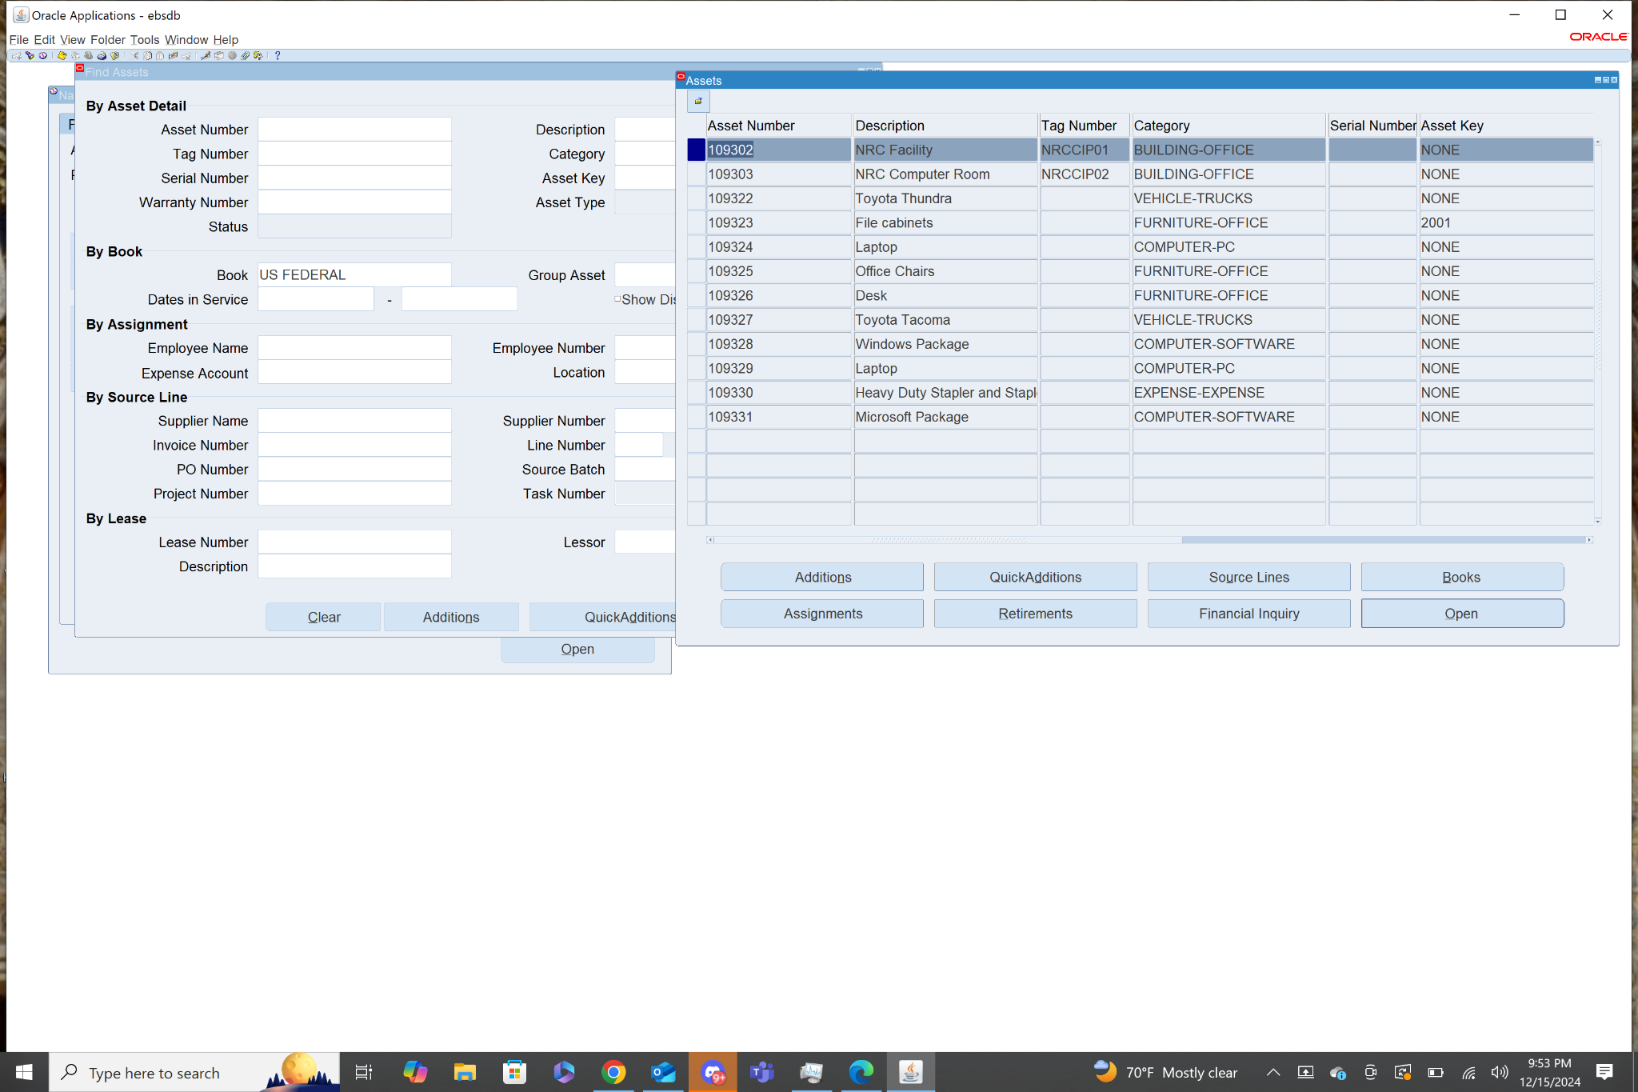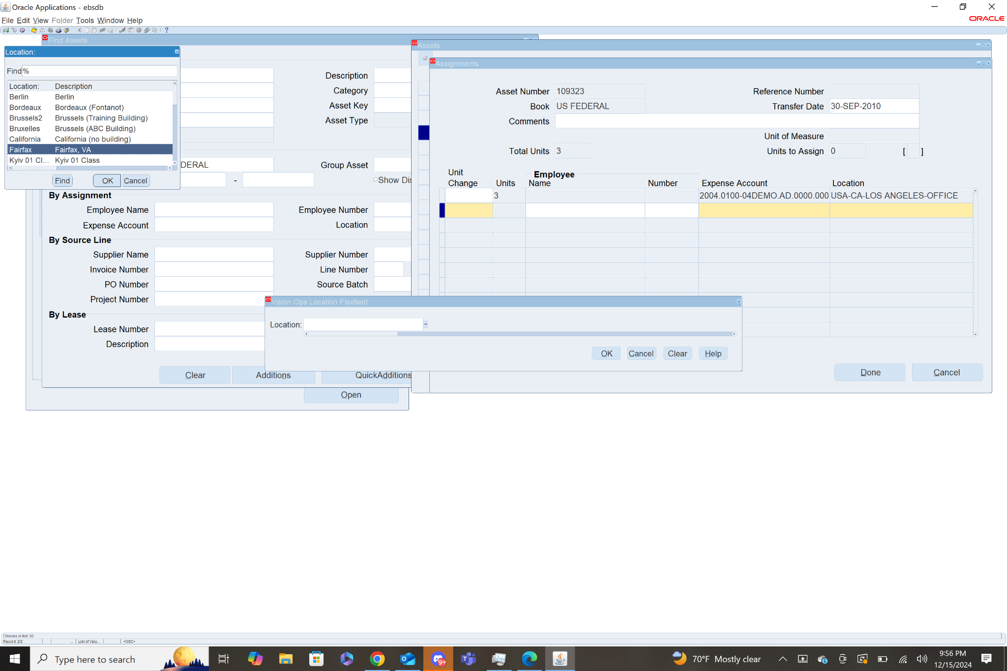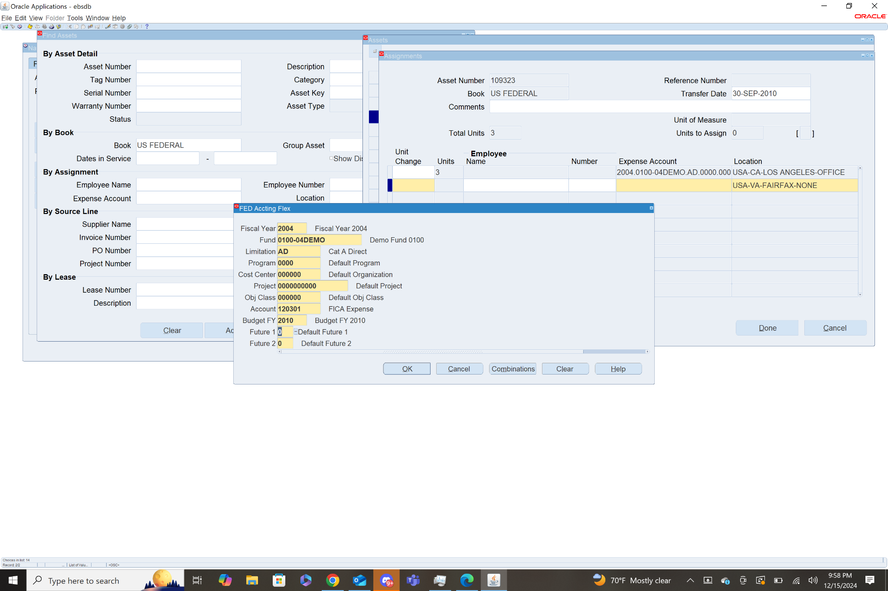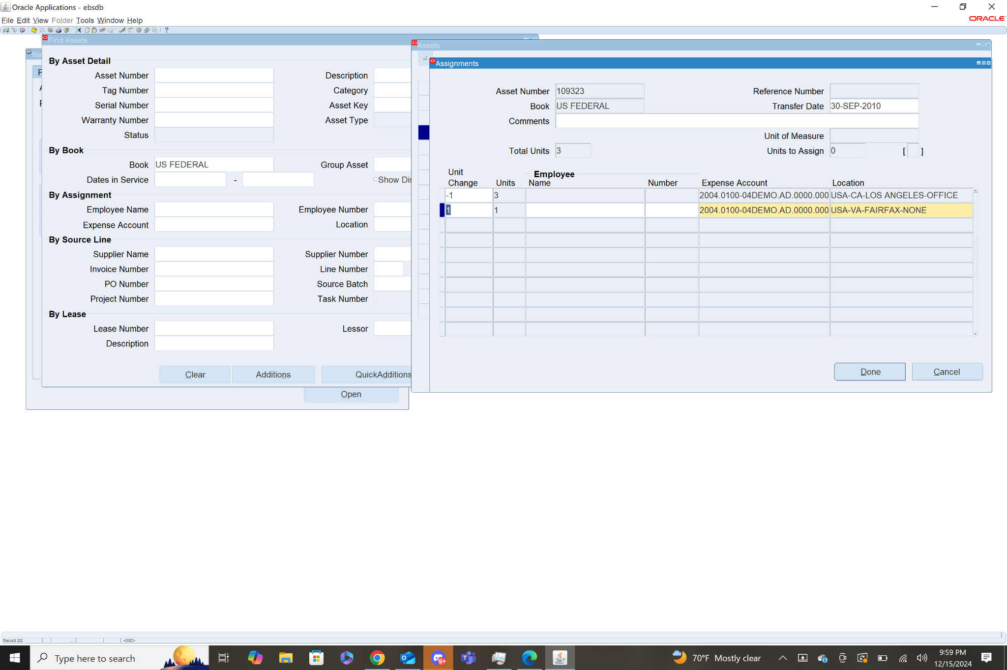

The above screenshots show the process of querying the assets. Selecting an asset, then going to the assignments page. I then put -1 in unit change for its current location. Then I created a new line with a new location and expense account for the asset to be transferred to. I tried to save but it gave an error because a depreciation request was being run on the US Federal book.

**5: Verify one of the Asset Details [Asset Book: US FEDERAL]**

Once the asset is added and assigned, you can review its details.

1. Navigate to: Fixed Assets > Assets > View Assets
2. Enter search criteria such as asset number or description to find and verify the asset details.

This is a very basic way to create and assign assets in Oracle EBS. Depending on your organization’s setup, the process may involve more complex configuration, but these are the fundamental steps for simple asset assignment. 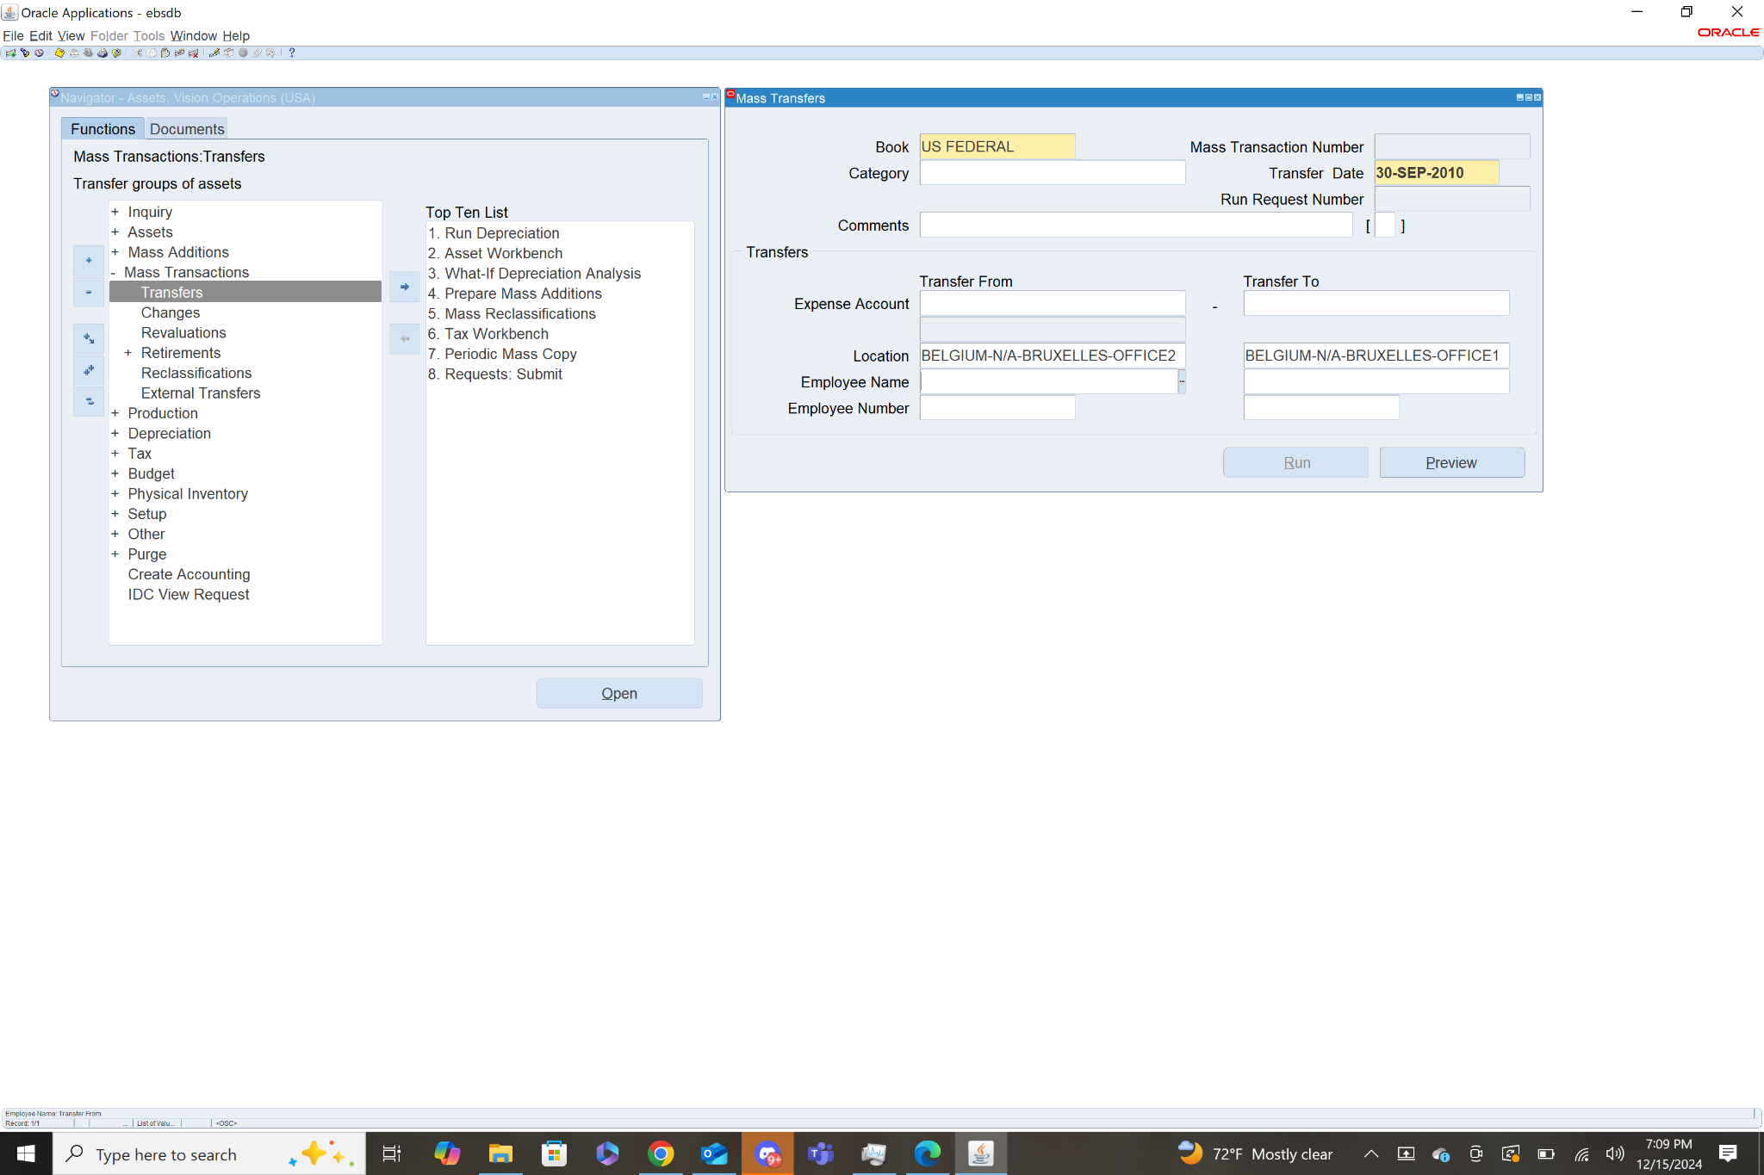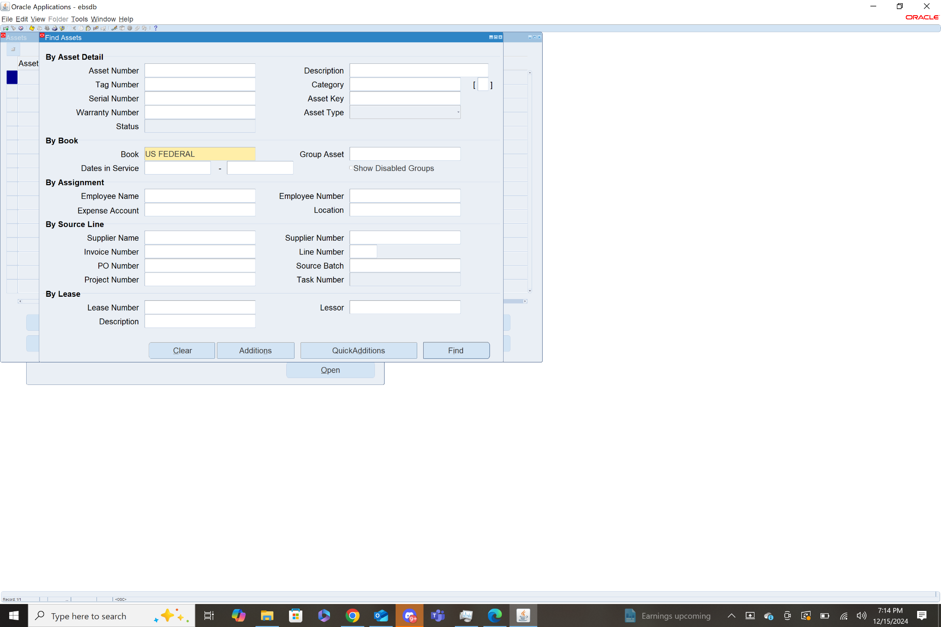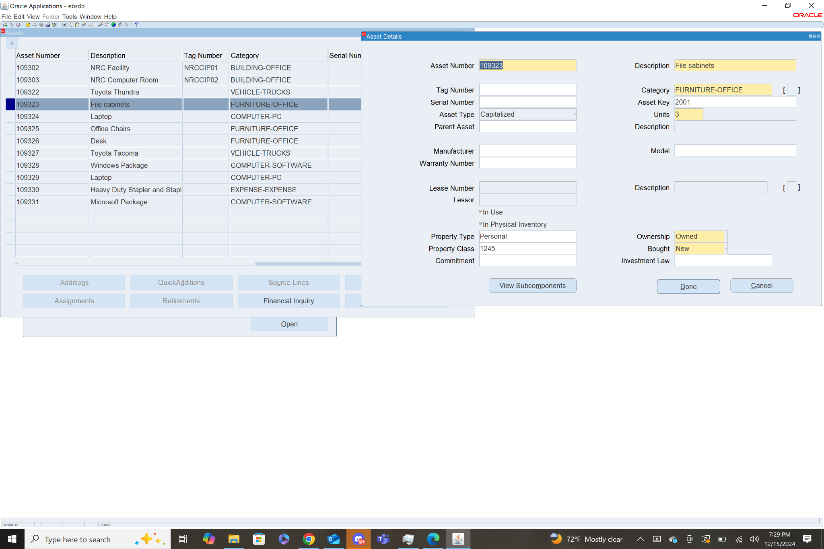

**6: For Asset Book: US FEDERAL how many Assets are there?**   
 Provide count with screen shot evidence.

There are 11 assets in the US FEDERAL Book. To find them go to asset workbench, which will open the find assets menu. From this menu choose US FEDERAL Book, then click find. This will show the Assets menu with a list of all assets in the US Federal book.

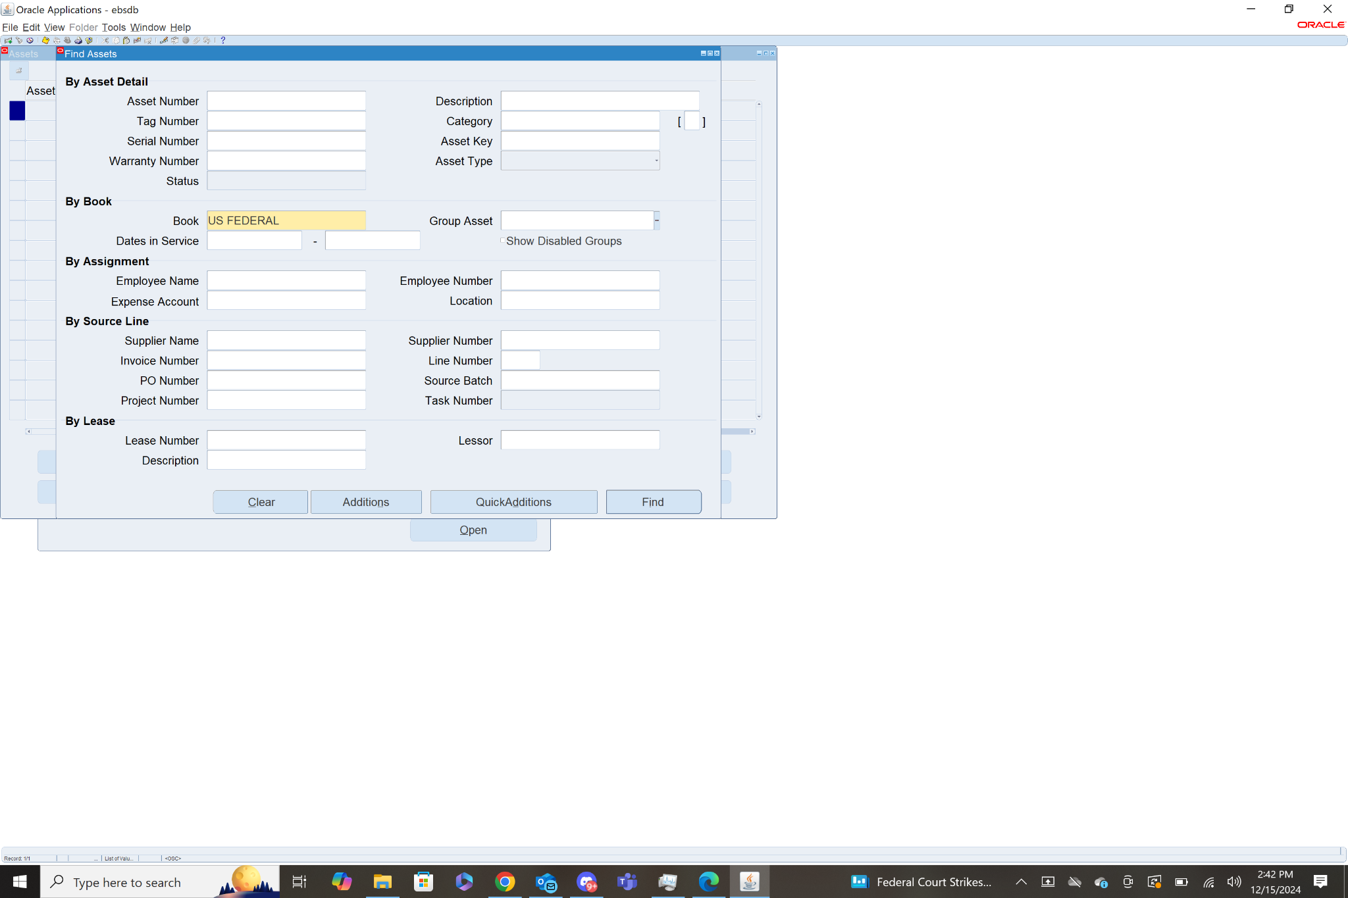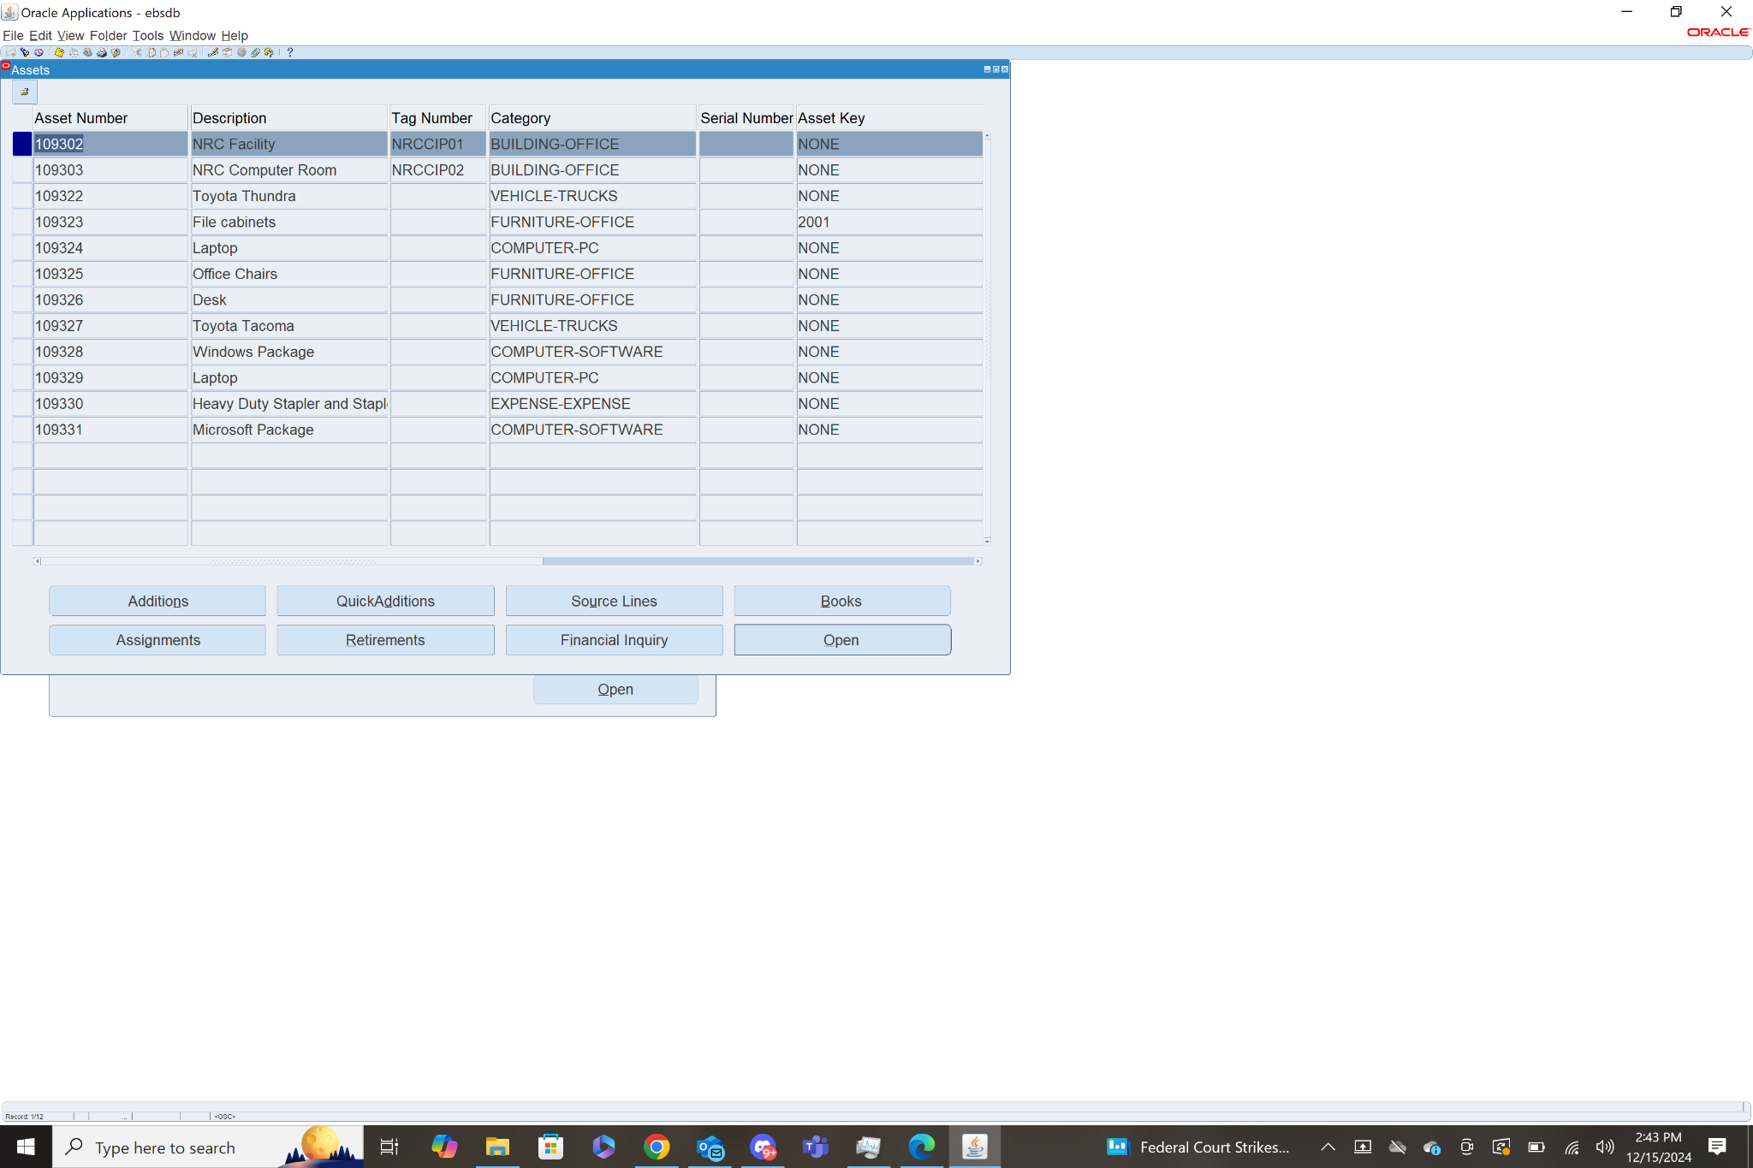

**8.Show me the all-Key Flex fields Details for Fixed Asset [ With Screen shot].**

Navigation: Assets>Asset Workbench

I queried assets for the book US FEDERAL, then selected the first fixed asset in that list and clicked on Open. That brought me to a page with the details for that fixed asset along with all of the key flex fields.

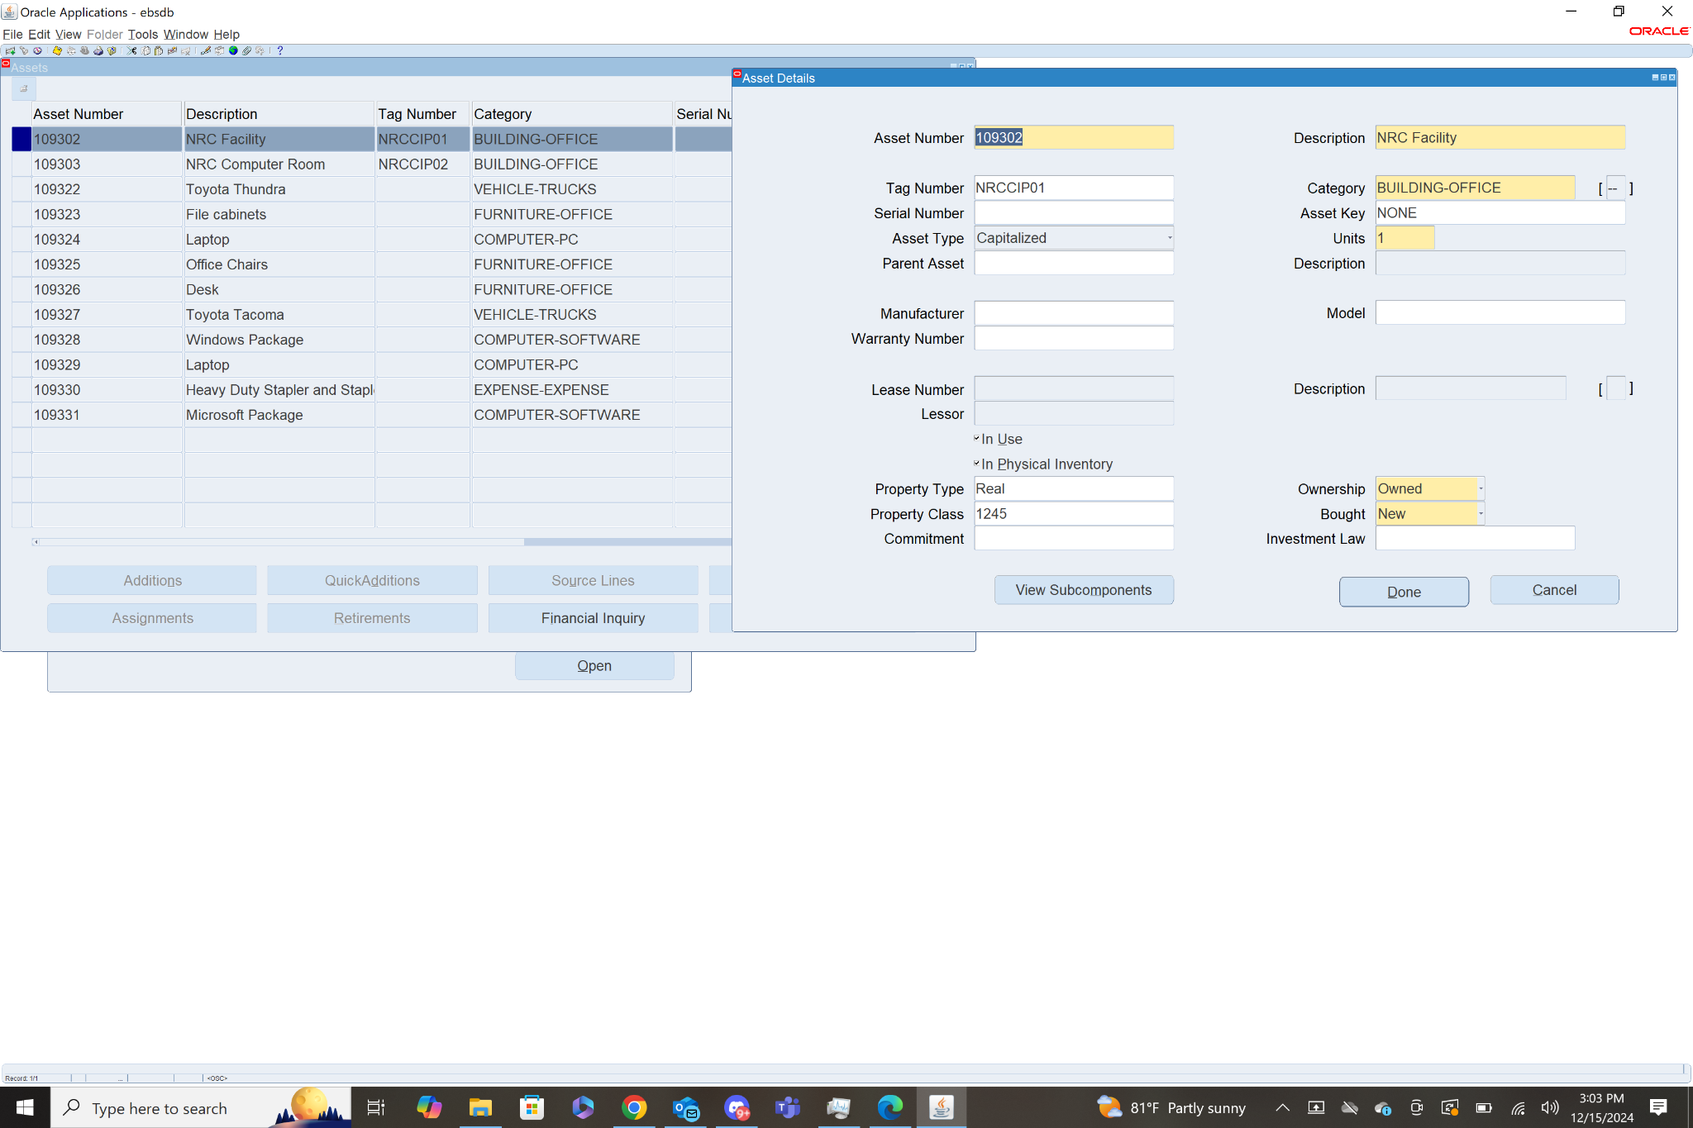

**9.For Asset Book: US FEDERAL find the following details…with screen shot**

**a) Depreciation Calendar.**    
 **b) Prorate Calendar**

**Navigation: Assets>Setup>Asset System>Book Controls**

This page shows several details of the Asset Book including the name of the Depreciation Calendar and Prorate Calendar. Both were named US Federal

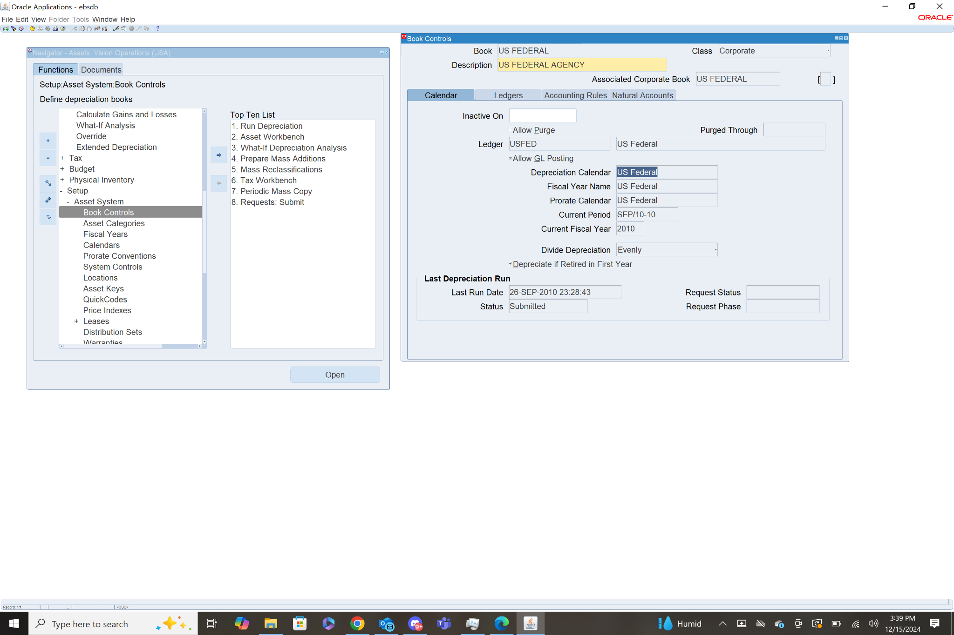

**10.What is Last Depreciation run for the Asset Book: US FEDERAL & what is the status?**

**Provide all the details with screen shot.**

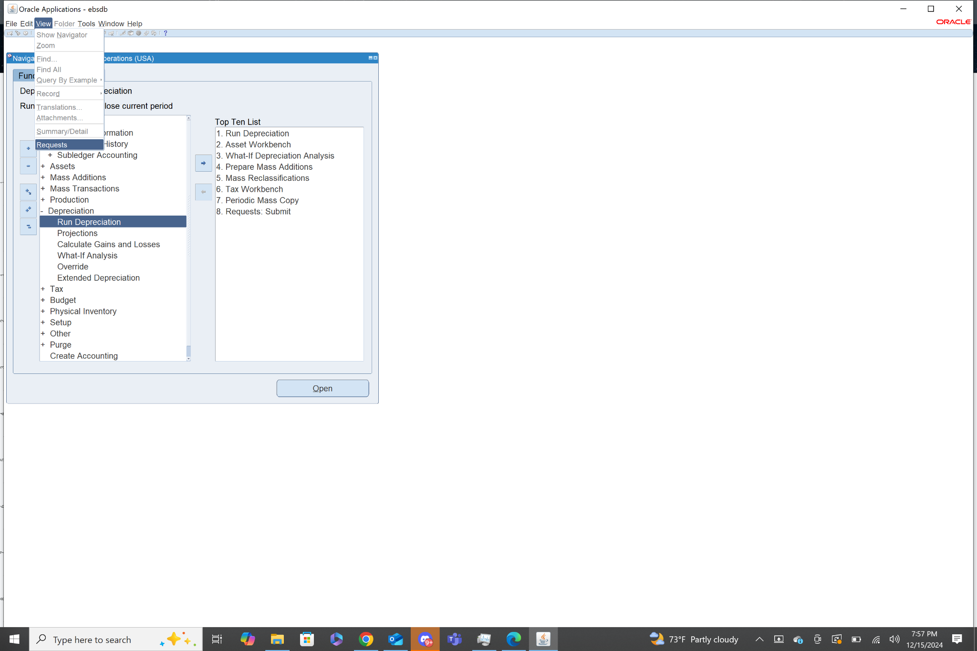

To Find the last depreciation ran, I clicked view then chose requests from the drop down. Then clicked Find for all the requests.

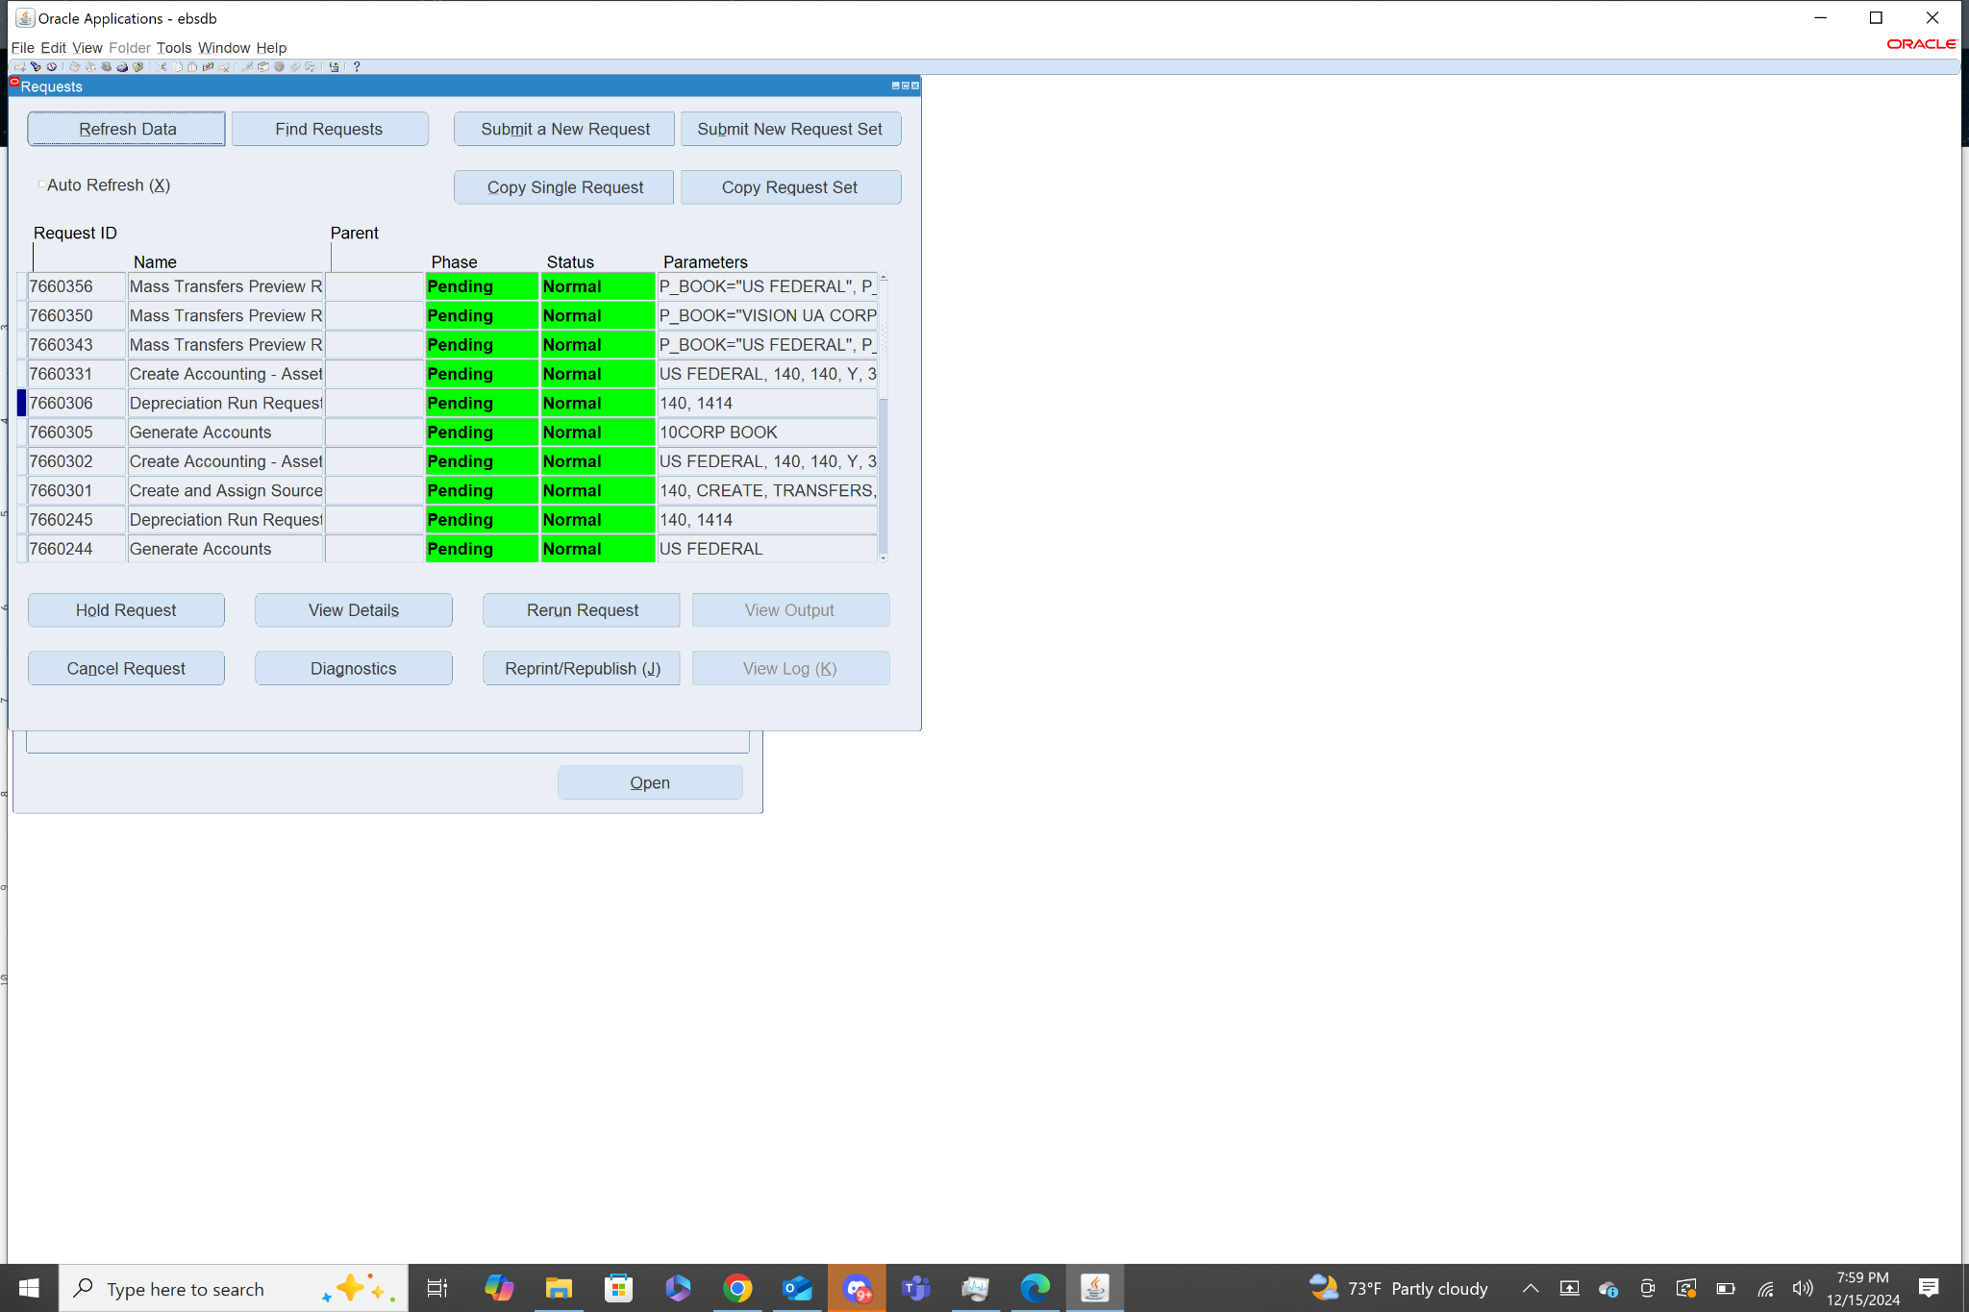

This pulls up all the request recently ran. I selected the most recent Depreciation run request and then hit view details.

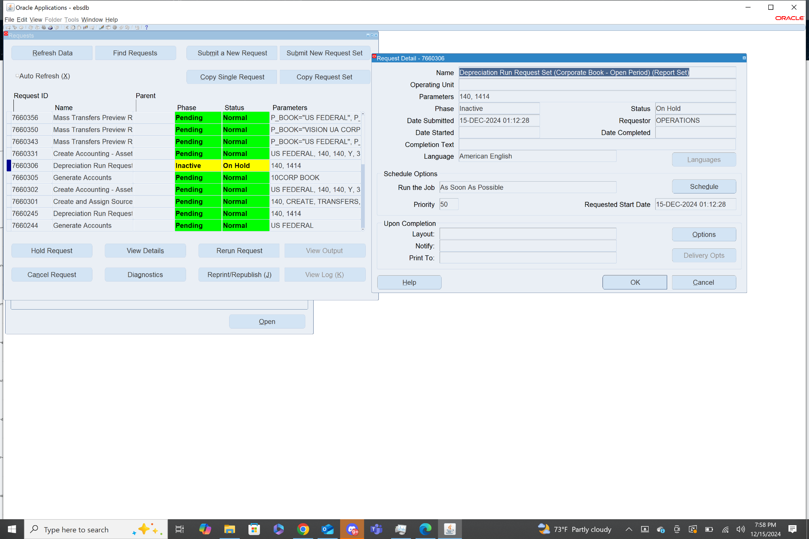

It shows that it was ran on December 15th, 2024. When I viewed the details it showed a status of hold, but when I closed out of the details it gave a status of normal. The parameters identify that it was ran for the asset book US FEDERAL.

**11.What Ledger associated with US FEDERAL Asset Book. (Provide the details with screen shot).**

**Navigation: Assets>Setup>Asset System>Book Controls**

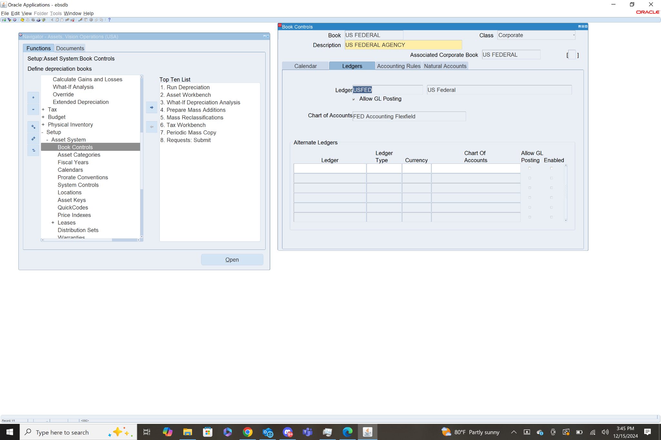

The ledger associated with US FEDERAL is USFED.

**12. What is Chart of accounts for US FEDERAL Asset Book. (Provide the details with screen shot).**

**Navigation: Assets>Setup>Asset System>Book Controls**



The COA for US FEDERAL asset book is FED Accounting Flexfield.

**13. System Control details for VISION ENTERPRISES.**

**Navigation: Assets>Setup>Asset System>System Controls**

